Group 11: Justin Farkas, Fiacre Indagiye Siboman, Young Jung, Jake Mecimore, Charles Valdez  
  
Use Case  
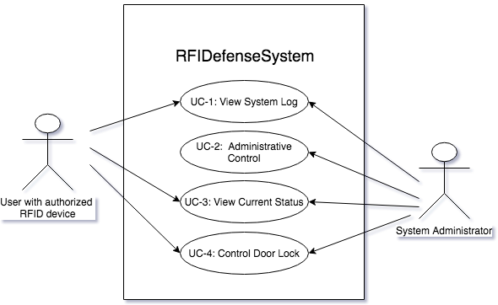

Door Lock Activity Diagram  
